**Location and date:**

* **Ballard High School on Saturday, 2/15/2025**
* Address: 1418 NW 65th St Seattle, WA 98117

**Meet Policies and Regulations:**

The meet shall be governed by WIAA rules and regulations.

**Meet Director**:

Darby Haskins – Nathan Hale HS [djhaskins@seattleschools.org](mailto:djhaskins@seattleschools.org) Cell Phone: 206-769-8972

**Meet Manager:**

Stephanie Gundel – Ballard HS [ballardgymnastics@gmail.com](mailto:ballardgymnastics@gmail.com) Cell Phone: 206-850-7800

**Games Committee:**

Darby Haskins or District 2 designee, one coach that is not involved and one official.

**School Roster:**

* Roster for team qualifiers are due to Stephanie Gundel by **2/12/2025**. This will be used for gym entry.
* Pass gate (use attached table) should include: coaches, attending administrator, athletic trainer, team photographer/videographer
* **If an athlete is not available to compete at the State meet, the athlete is not eligible to compete at the District meet.**
* Non-competing gymnasts will need to purchase a ticket to attend.

**Admission Prices**: Physical tickets will not be sold. E-tickets can be purchased GoFan.com either before the meet or at the meet (note: they will still need to be purchased online at the door).  THERE WILL NOT BE A CASH BOX ON SITE. Directions are on page 3.

* Cheerleaders in uniform/team sweats will be admitted free (to be seated in the stand, not floor access).
* Adults, student w/o ASB - $9 base ticket price plus online fee
* Seniors, students with ASB, K-8 - $6 base ticket price plus online fee
* Pre-school and under – no charge

**Passes:** WSSAAA, WIAA and District 2 passes are the only passes that will be honored.

**Inquiry Forms**: Will be provided. Inquiries must be completed and turned in before the end of each rotation. Inquires will follow the WIAA Inquiry Policy.

**Sportsmanship/Spirit: Signs, Flags, Noisemakers, Bands**

* Each school may have one official school banner.
* Noisemakerswill not be allowed. Any fan unwilling to give up noisemaker(s) will be removed.
* No handheld signs including big heads.
* No balloons.
* No flash photography.
* No distractions of any kind.

**Post Season Playoff Supervision:**

Each school should have an administrator or designee present for crowd control issues with their fans. It is not the job of the tournament director or meet managers to address fan behavior during the meet.

**Medical and Athletic Training**: There will be a trainer on site for all sessions. Each school needs to provide their own tape, pro wrap and supplies. Please bring your training kits.

**Equipment:** There will be all necessary equipment at each event including sting mats, 4” & 8” mats, extra springboards, panel mats, a safety zone, and a round off entry mat.

**Music:**  Each school will provide their own music in a digital format. There will be Bluetooth connection available and an aux cord for iPhones. All music must be downloaded onto a device – no streaming.

**Rotations:** Rotations will be emailed the week of the District meet.

**Entries:** Team qualifiers can compete a max of 6 athletes per event.

**Meet Format**: Warm up four events. There will be a one touch warm up for each event.

**Allocations:**

From League to District:

* Metro: Team 3; All Around 3; Individuals 11
* KingCo: Team 3; All Around 5; Individuals 13

From District to State

* 3 teams 4 AAs 12 Individuals

**Crowd Control:** The floor is limited to athletes competing. Athletes that are not competing need to be in the stands.

**Belongings:** Ballard High School in not responsible for the safety of belongings. Athletes need to keep belongings

with them.

**Time Schedule:** Specific time schedule will be sent out with the draw the week of 2/10/25.

**Awards:** Immediately following the last session. Pictures of qualifiers for the state program are taken after awards; all qualifiers need to be present for awards.



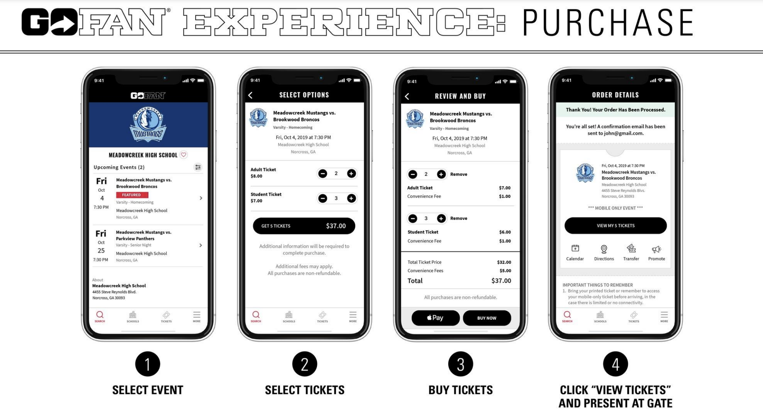

**TO REDEEM:**

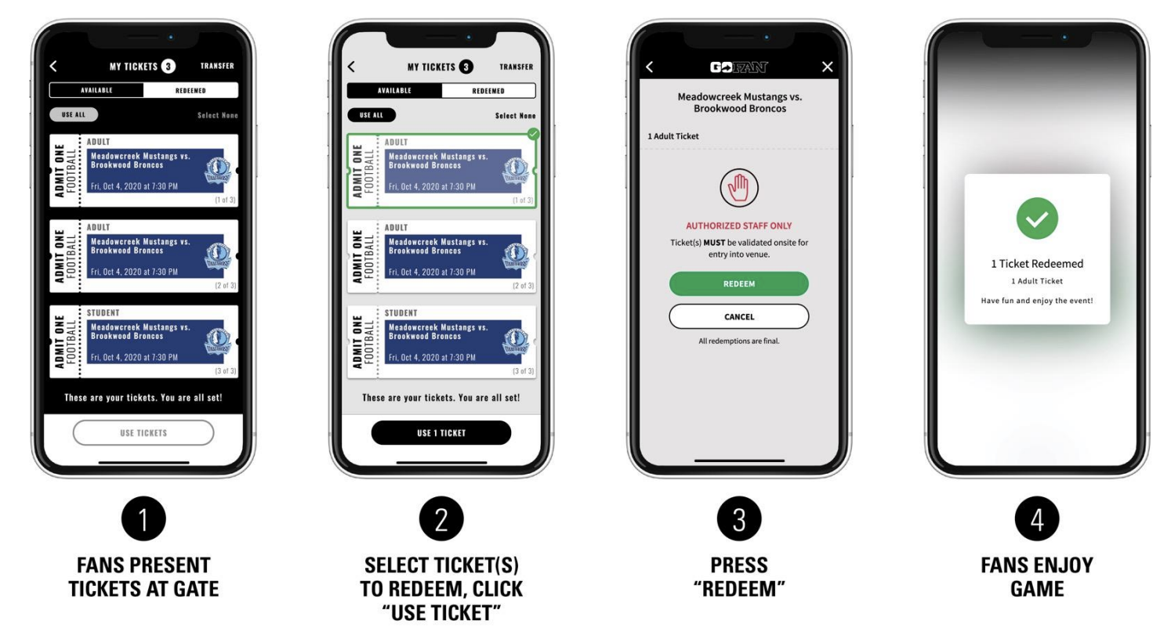

|  |  |  |  |  |  |  |
| --- | --- | --- | --- | --- | --- | --- |
| **School:** |  |  |  | |  | |
|  |  |  |  | |  | |
| **Head Coach:** |  |  |  | |  | |
|  |  |  |  | |  | |
| **Assistant Coach:** |  |  |  | |  | |
|  |  |  |  | |  | |
| **Assistant Coach:** |  |  |  | |  | |
|  |  |  |  | |  | |
| **Administration:** |  |  |  | |  | |
| **Competing Athletes:** | |  |  | |  | |
| **Last Name** | **First Name** |  | **Year (**9,10,11,12) | |  | |
|  |  |  | |  | |
|  |  |  | |  | |
|  |  |  | |  | |
|  |  |  | |  | |
|  |  |  | |  | |
|  |  |  | |  | |
|  |  |  | |  | |
|  |  |  | |  | |
|  |  |  | |  | |
|  |  |  | |  | |
|  |  |  | |  | |
|  |  |  | |  | |
|  |  |  | |  | |
|  |  |  | |  | |
|  |  |  | |  | |
|  |  |  | |  | |
|  |  |  | |  | |
|  |  |  | |  | |
|  |  |  |  | |  | |