**2024-2025 SEA-KING DISTRICT II 1A/2A, 3A, and 4A BOYS SWIMMING AND DIVING CHAMPIONSHIPS**

## February 14 and 15, 2025

|  |  |  |
| --- | --- | --- |
| **Meet Contacts** | **Email** | **Phone Contact** |
| Jeff Lowell, Meet Director | [lowellj@bsd405.org](mailto:lowellj@bsd405.org) | (425) 428-3335 |
| Skip Hulet, Diving Referee | [bhulet@lwsd.org](mailto:BHULET@lwsd.org) | (206) 390-4359 |
| TBD, 3A Meet Referee |  |  |
| TBD, 1A/2A and 4A Meet Referee |  |  |

|  |  |
| --- | --- |
| **Sites** | **Phone** |
| Hazen Pool, 1101 Hoquiam Ave NE, Renton, WA 98059 | (425) 204-4230 |
| Mary Wayte Pool, 8815 SE 40th St, MI, WA 98040 | (206) 588-1117 |
| Lindbergh Pool 16740 128th Ave SE, Renton, WA 98058 | (425) 204-4440 |

**DATE & TIME:**



|  |  |  |  |  |  |  |
| --- | --- | --- | --- | --- | --- | --- |
| **Friday** |  |  | **Participating Teams** | | | |
| **1A/2A Prelims** | 12:00 PM | Facility Opens | Chief Sealth | Nathan Hale |  |  |
| **Hazen** | 12:15 PM | Coaches meeting | Cleveland | Renton |  |  |
|  | 12:30 PM | Warm-up (pool closes at 1:10 PM) | Evergreen | South Whidbey |  |  |
|  | 1:30 PM | Swim prelims | Foster | Tyee |  |  |
|  | 3:45 PM | Competition Ends (Approx) | Lindbergh |  |  |  |
| **4A Prelims** | 4:15 PM | Facility Opens | Bothell | Lake Washington | Redmond |  |
| **Hazen** | 4:30 PM | Coaches meeting | Eastlake | Lincoln | Skyline |  |
|  | 4:45 PM | Warm-up (pool closes at 5:40 PM) | Hazen | Mount Si | Woodinville |  |
|  | 5:45 PM | Swim prelims | Issaquah | Newport |  |  |
|  | 8:00 PM | Competition Ends (Approx) | Juanita | North Creek |  |  |
| **3A Prelims** | 12:00 PM | Facility Opens | Bishop Blanchet | Mercer Island |  |  |
| **Mary Wayte** | 12:15 PM | Coaches meeting | Franklin | Roosevelt |  |  |
| **SESSION 1** | 12:30 PM | Warm-up (pool closes at 1:25 PM) | Garfield | Seattle Prep |  |  |
|  | 1:30 PM | Swim prelims | Lakeside | West Seattle |  |  |
|  | 3:45 PM | Competition Ends (Approx) | Liberty |  |  |  |
| **3A Prelims** | 4:15 PM | Facility Opens | Ballard | Ingraham |  |  |
| **Mary Wayte** | 4:30 PM | Coaches meeting | Bellevue | Interlake |  |  |
| **SESSION 2** | 4:45 PM | Warm-up (pool closes at 5:40 PM) | Eastside Catholic | O’Dea |  |  |
|  | 5:45 PM | Swim prelims | Highline | Sammamish |  |  |
|  | 8:00 PM | Competition Ends (Approx) | Inglemoor |  |  |  |
| **Saturday** |  |  |  | | | |
| **1A/2A Diving** | 6:45 AM | Facility Opens | Chief Sealth | Nathan Hale | Issaquah | Newport |
| **4A Diving** | 7:00 AM | Warm-up (pool closes at 8:10 AM) | Cleveland | Renton | Juanita | North Creek |
| **(Lindbergh)** | 8:15 AM | Diving Prelims, Semis, Finals | Tyee / Evergreen | Bothell | Lake Washington | Redmond |
|  | 11:00 AM | Competition Ends (Approx) | Foster / S. Whidbey | Eastlake | Lincoln | Skyline |
|  |  |  | Lindbergh | Hazen | Mount Si | Woodinville |
| **3A Diving** | 10:45 AM | Facility Opens | Ballard | Garfield | Lakeside | Sammamish |
| **(Lindbergh)** | 11:00 AM | Warm-up (pool closes at 12:10 PM) | Bellevue | Highline | Liberty | Seattle Prep |
|  | 12:15 PM | Diving Prelims, Semis, Finals | Bishop Blanchet | Inglemoor | Mercer Island | West Seattle |
|  | 3:00 PM | Competition Ends (Approx) | Eastside Catholic | Ingraham | O’Dea |  |
|  |  |  | Franklin | Interlake | Roosevelt |  |
| **1A/2A FINALS** | 12:00 PM | Facility Opens | Chief Sealth | Nathan Hale |  |  |
| **Hazen** | 12:15 PM | Coaches meeting | Cleveland | Renton |  |  |
|  | 12:30 PM | Warm-up (pool closes at 1:25 PM) | Evergreen | South Whidbey |  |  |
|  | 1:30 PM | Swim Finals | Foster | Tyee |  |  |
|  | 3:45 PM | Competition Ends | Lindbergh |  |  |  |
| **4A FINALS** | 4:15 PM | Facility Opens | Bothell | Lake Washington | Redmond |  |
| **Hazen** | 4:30 PM | Coaches meeting | Eastlake | Lincoln | Skyline |  |
|  | 4:45 PM | Warm-up (pool closes at 5:40 PM) | Hazen | Mount Si | Woodinville |  |
|  | 5:45 PM | Swim Finals | Issaquah | Newport |  |  |
|  | 8:00 PM | Competition Ends | Juanita | North Creek |  |  |
| **3A Finals** | 4:15 PM | Facility Opens | Ballard | Garfield | Interlake | Sammamish |
| **Mary Wayte** | 4:30 PM | Coaches meeting | Bellevue | Highline | Lakeside School | Seattle Prep |
|  | 4:45 PM | Warm-up (pool closes at 5:40 PM) | Bishop Blanchet | O’Dea | Liberty | West Seattle |
|  | 5:45 PM | Swim Finals | Eastside Catholic | Inglemoor | Mercer Island |  |
|  | 8:00 PM | Competition Ends | Franklin | Ingraham | Roosevelt |  |

**1A/2A, 3A and 4A SeaKing District 2 Games Committee:** The duties of the Games Committee are as follows:

1. Assist the Tournament Manager as needed and be available during the event.
2. Act as an arbitration board for disputes and respond to special concerns. Final decisions shall be made by consensus of the Games Committee. If a coach on the committee is involved in the protest, a coach with no conflict will take their place.
3. Respond to alleged infractions or rule violations from participating coaches and/or administrators - not contestants.

* Jeff Lowell, Meet Director
* TBD, Meet Referee
* Deck Referee
* Eric Bartleson, Meet Manager
* Julie Barashkoff, Head Coach Redmond High School / Roger Miron, Head Coach Lindbergh High School / Laura Halter, Head Coach Issaquah High School

**ENTRIES & REGISTRATION:** To complete your entries, you **MUST** submit **THREE** things by Sunday, February 9, 2025, by NOON:

1. A Team Manager export of your meet entries
   1. **1A/2A Prelims = Events 201-212,**
   2. **3A Prelim Session #1 = Events 301-312, 3A Prelim Session #2 = Events 101-112,**
   3. **4A Prelims = Events 401-412**
   4. When exporting from Team Manager, ENTER WILD CARD HOPEFULS. Please use the BONUS EVENT option in Team Manager to mark any WILD CARD HOPEFUL.
   5. When exporting from Team Manager, ENTER ALL DIVERS WHO WILL COMPETE – if a diver is not part of the export file, THEY HAVE NOT BEEN ENTERED IN THE MEET.
2. A Team Manager printout of your entries, including divers and relay names.
   1. When creating the file – please send entries by NAME and include PROOF OF TIME in pdf format.
   2. For those without TM, contact Jeff directly to discuss entries.
3. Timer’s Names

### Please send all information through EMAIL to Jeff Lowell at [lowellj@bsd405.org](mailto:lowellj@bsd405.org). If you have issues during this process, do not wait – call Jeff at 425-428-3335.

**Entry Info: Please remember the following items when entering athletes:**

1. **Entry Limits:** An athlete may enter a maximum of 2 individual events and 3 relays. However, an athlete may only compete in a maximum of four events: two individual events and two relays or one individual event and three relays. *PRELIMS and FINALS are separate sessions of the same meet.*
2. **Team Entry Limits:** Each team may enter a maximum of **four swimmers per individual event,** with qualifying District times, on the Master Entry Form
3. **Relay entry times:**  Each team may submit a ***single-entry time for each relay* with *up to 8*** potential swimmers for that relay.

**Master Entries in TM must be complete and accurate**

1. List swimmers’ first & last names and grades. Enter full name, grade level, and best **verifiable interscholastic performance time from the 2024-2025 season. This is the reason for the PROOF OF TIME on the TM report. Without the PROOF OF TIME, entries will not be accepted.**
2. List ALL relay alternates in TM – as THESE ARE STATE RELAY ENTRIES AS WELL.
3. **AGAIN,** **PLEASE ADD POTENTIAL WILD CARD TIMES INTO TM.** Athletes do not receive consideration if you do not enter them into TM. Athletes are added on a space available basis. Coaches will know if athletes are added as they will be on the preliminary psych sheet, which will be released by Sunday evening (9 pm). The following information describes how wild card hopefuls are entered in the meet.

* IF there are empty lanes available (to fill a heat with qualified athletes) in an event after the qualified swimmers have been seeded, swimmers nominated as ‘Wild Card Entries’ will be entered, based on time, until all empty lanes in an event are filled. **No new heats will be created**.
* Entry times must be the best verifiable time from the current season. AGAIN - INCLUDE PROOF OF TIME
* A ‘Wild Card Entry’ counts toward the individual event limit of 2 per swimmer even if a swimmer is not ultimately entered in the event. Wild card hopefuls also count against the 4-athlete limit in each individual event.
* THERE WILL BE NO WILD CARD ENTRIES ADDED AT THE MEET. IF THERE ARE SCRATCHES, LANES WILL BE LEFT OPEN.

1. Coaches’ contact phone numbers and email addresses are needed for questions regarding entries (please list the number at which you are most likely to be reached).
2. **Relay Entries may include up to 8 athletes for each of the three relays.**
   1. Each relay lineup (prelims or finals) may *only include athletes originally designated as potential participants in TM.*
   2. If a swimmer is entered in all three relays, it is the coach’s responsibility to see that the swimmer does not compete on all three relays if that would put the swimmer over the limit of competing in 4 events.
   3. ***The same eight athletes remain on a relay if it should advance to the State Meet****.* WIAA rules forbid changes to the 8 potential members of a relay between Districts and State. Any combination of these 8 athletes may swim in prelims and/or finals at the District Meet and State, subject to the usual athlete event limits.

#### Diving: Divers will be fully entered after they are entered in Clean Entries. Dive Coaches need to use instructions provided earlier in the season. If instructions are needed again, access them through this link ([Clean Entries](https://bsd405-my.sharepoint.com/:w:/g/personal/lowellj_bsd405_org/Ed-gcMZzTKRPv98E3zeYvUMBAExLi6rnUbD82_bfraXIXQ?e=WcV9gq)) or contact Jeff, Skip, or Todd.

##### SEATING & ENTRY:

##### Except for athletes, meet officials and timers, ALL other students and parents MUST pay. Spectators will sit upstairs. Only coaches, athletes and meet workers will be allowed on the pool deck. All coaches and workers will wear a pass to be on deck.

**COACHES:**

* Please adhere to the ‘DOORS OPEN’ portion of the schedule. Arriving too early does complicate things for the event workers.
* Please pick up your heat sheets, deck pass and other information from the meet manager upon arrival before the coaches meeting.
* Please help us to keep the pool deck and spectator areas picked up and clean.
* Instruct your athletes to not leave ANYTHING in the locker room unattended.

**State Meet Qualification**: Qualification for the WIAA State Meet is possible by any of three methods:

1. Allocations from District 2 to the State Meet: ***Individual and relay events:***
   1. ***1A/2A will have 3 allocations***
   2. ***3A will have 5 allocations***
   3. ***4A will have 4 allocations***
2. Individuals or relays may also qualify by achieving the State time standard for that event subject to the following criteria:
   1. *A qualifying time, intended to be used for entry into the state meet, must be submitted to the WISCA database within 7 days of achieving the time, on the entry card or electronic printout showing the time, signed by the meet Referee. Make sure you have submitted your State athletes’ times to WISCA in accordance with the rules on the WIAA website.*
   2. *The meet director will submit state times achieved at Districts for you.*
   3. NOTE: Athletes or divers who wish to compete at the State Meet must compete in the same event(s) at their district meet.
3. If space is available in the State Meet it is possible for an athlete to receive an information for a spot (i.e. a wild card entry) in an event based on the time achieved in finals at the District Meet. The process for wild card entries is posted at <http://wiscaorg.ipage.com/state-info.php>.

**QUALIFYING STANDARDS can be found on the** [**WIAA Swim and Dive webpage**](https://assets-rst7.rschooltoday.com/rst7files/uploads/sites/772/2023/08/09020802/State-Qualifying-Standards.pdf)

**SEEDING and SCORING:** Championship seeding and scoring

|  |  |  |  |  |  |  |  |  |  |  |  |  |
| --- | --- | --- | --- | --- | --- | --- | --- | --- | --- | --- | --- | --- |
| **Place** | **1st** | **2nd** | **3rd** | **4th** | **5th** | **6th** | **7th** | **8th** | **9th** | **10th** | **11th** | **12th** |
| Ind Pts | 16 | 13 | 12 | 11 | 10 | 9 | 7 | 5 | 4 | 3 | 2 | 1 |
| Relay Pts. | 32 | 26 | 24 | 22 | 20 | 18 | 14 | 10 | 8 | 6 | 4 | 2 |

**Breaks/Warm-Ups/Awards Presentations:**

|  |  |  |  |
| --- | --- | --- | --- |
| **Event** | **Prelim Sessions- Friday** | **Event** | **Swimming Finals - Saturday** |
| **1** | **200 Medley Relay Heats** | **1** | **200 Medley Relay Consolation Finals** |
|  |  |  | **200 Medley Relay Final** |
|  | Break - 5 min Competition Pool is Open |  | Break - 5 min Competition Pool is Closed |
| **2** | **200 Freestyle Heats** | **2** | **200 Freestyle Consolation Finals** |
|  |  |  | **200 Freestyle Final** |
| **3** | **200 Individual Medley Heats** | **3** | **200 Individual Medley Consolation Finals** |
|  |  |  | **200 Individual Medley Final** |
| **4** | **50 Freestyle Heats** | **4** | **50 Freestyle Consolation Finals** |
|  |  |  | **50 Freestyle Final** |
|  | Break - 15 min Competition Pool is Open |  | Break –15 min Competition Pool Open |
|  |  |  | Awards for Events 1 - 5 |
| **6** | **100 Butterfly Heats** | **6** | **100 Butterfly Consolation Finals** |
|  |  |  | **100 Butterfly Final** |
| **7** | **100 Freestyle Heats** | **7** | **100 Freestyle Consolation Finals** |
|  |  |  | **100 Freestyle Final** |
| **8** | **500 Freestyle Heats** | **8** | **500 Freestyle Consolation Finals** |
|  |  |  | **500 Freestyle Final** |
|  | Break - 5 min Competition Pool is Open |  | Break – 5 min Competition Pool Open |
|  |  |  | Awards for Events 6-8 |
| **9** | **200 Free Relay Heats** | **9** | **200 Free Relay Consolation Finals** |
|  |  |  | **200 Free Relay Final** |
|  | Break - 5 min Competition Pool is Open |  | Break - 5 min Competition Pool is Closed |
|  |  |  | Awards for Event 9 |
| **10** | **100 Backstroke Heats** | **10** | **100 Backstroke Consolation Finals** |
|  |  |  | **100 Backstroke Final** |
| **11** | **100 Breaststroke Heats** | **11** | **100 Breaststroke Consolation Finals** |
|  |  |  | **100 Breaststroke Final** |
|  | Break - 5 min Competition Pool is Open |  | Break - 5 min Competition Pool is Closed |
|  |  |  | Awards for Events 10 - 11 |
| **12** | **400 Free Relay Heats** | **12** | **400 Free Relay Consolation Finals** |
|  |  |  | **400 Free Relay Final** |
|  |  |  | Awards for Event 12 |
| **5** | **1 M Diving Heats** | **5** | **1 M Diving Final** |
|  | COMPLETED DURING DIVING SESSIONS |  | COMPLETED DURING DIVING SESSIONS |

**AWARDS:**

1. A trophy will be awarded for the first-place team.
2. Medals will be awarded for 1st through 3rd place for all events.

Meet Mobile will be available for this meet (1a2a SeaKing Boys 2025, 3A SeaKing Boys 2025, or 4A SeaKing Boys 2025). Psych sheet for 1A/2A, 3A, and 4A finals will be posted at <https://wiscaorg.ipage.com/results/league.php>.

**GoFan Online Ticketing will be used for the event.** Specific information will be provided to each coach the Monday prior to the meet.

**GATE LIST WILL BE PULLED FROM THE WIAA’s TOWER PLATFORM (FINAL FORMS)**

**QUESTIONS:** Please call Jeff Lowell, Meet Manager, at (425) 428-3335 or email at [lowellj@bsd405.org](mailto:lowellj@bsd405.org).

## **VOLUNTEER SHEET: Please list the names of your volunteers on the sheet provided and return it with your entries:**

## **Each team will be responsible for providing some volunteer help to ensure the meet is a success. Please list the names of your volunteers on the sheet provided and return it with your entries. The main volunteer help will be with timing the meet. The number of timers each team is responsible for is as follows:**

|  |  |  |  |
| --- | --- | --- | --- |
| **Lane #** | **School** | **Timer Name** | **Timer Name** |
| **1A/2A Prelim Session** |
| 1 | Filled by RSD |  |  |
| 2 |  |  |  |
| 3 |  |  |  |
| 4 |  |  |  |
| 5 |  |  |  |
| 6 |  |  |  |
| Backup |  |  |  |
| **1A/2A Finals** | **School** | **Timer Name** | **Timer Name** |
| 1 | Filled by RSD |  |  |
| 2 |  |  |  |
| 3 |  |  |  |
| 4 |  |  |  |
| 5 |  |  |  |
| 6 |  |  |  |
| Backup |  |  |  |
| **3A Prelim Session #1** | **School** | **Timer Name** | **Timer Name** |
| 1 | Seattle Prep / Bishop Blanchet (1 each) |  |  |
| 2 | Liberty |  |  |
| 3 | Mercer Island |  |  |
| 4 | Lakeside |  |  |
| 5 | Roosevelt |  |  |
| 6 | Garfield |  |  |
| Backup | Franklin / West Seattle (1 each) |  |  |
| **3A Prelim Session #2** | **School** | **Timer Name** | **Timer Name** |
| 1 | Ballard |  |  |
| 2 | Inglemoor |  |  |
| 3 | Bellevue |  |  |
| 4 | O’Dea |  |  |
| 5 | Ingraham / Interlake (1 each) |  |  |
| 6 | Sammamish |  |  |
| Backup | Eastside Catholic / Highline (1 each) |  |  |
| **3A Finals** | **School** | **Timer Name** | **Timer Name** |
| 1 | Seattle Prep / Bishop Blanchet (1 each) |  |  |
| 2 | Bellevue |  |  |
| 3 | Lakeside |  |  |
| 4 | Mercer Island |  |  |
| 5 | O’Dea |  |  |
| 6 | Roosevelt |  |  |
| Backup | Bishop Blanchet / Ballard (1 each) |  |  |
| **4A Prelim Session** | **School** | **Timer Name** | **Timer Name** |
| 1 | Eastlake / Redmond (1 each) |  |  |
| 2 | Lake Washington / Newport (1 each) |  |  |
| 3 | Hazen / Issaquah (1 each) |  |  |
| 4 | Lincoln / North Creek (1 each) |  |  |
| 5 | Woodinville/Juanita (1 each) |  |  |
| 6 | Skyline |  |  |
| Backup | Bothell / Mt. Si (1 each) |  |  |
| **4A Finals** | **School** | **Timer Name** | **Timer Name** |
| 1 | Eastlake / Redmond (1 each) |  |  |
| 2 | Lake Washington / Newport (1 each) |  |  |
| 3 | Hazen / Issaquah (1 each) |  |  |
| 4 | Lincoln / North Creek (1 each) |  |  |
| 5 | Woodinville/Juanita (1 each) |  |  |
| 6 | Skyline |  |  |
| Backup | Bothell / Mt. Si (1 each) |  |  |

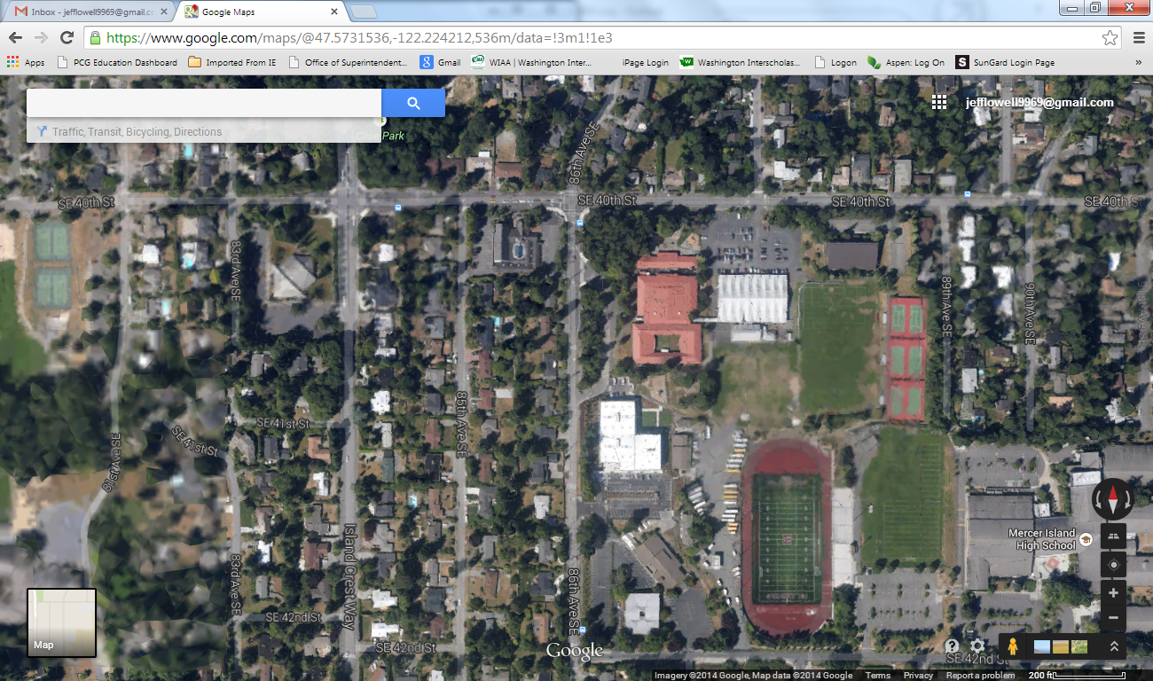

**Parking at the North Mercer Campus will be shut down.**

**School parking will mean**

**spectators need to park**

**elsewhere.**

**Additional parking at:**

**Mercer Island Presbyterian Church**

3605 84th Ave SE – off Island Crest Way

approx.. .4 miles away from the pool

**There are 60 spots available at Holy Trinity Lutheran.**

**Address: 8501 SE 40th St**

**Mary Wayte Pool**

**8815 SE 40th,**

**Mercer Island, WA**

**(206) 588-1117**

**SE 40th is the street**

**in front of the pool.**

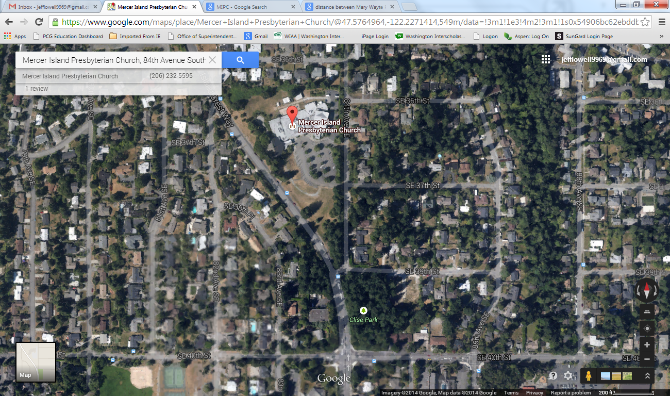

**Path to walk back to the pool. There are two options**

**Pool Campus**

**Additional parking at:**

**Mercer Island**

**Presbyterian Church**

3605 84th Ave SE

off Island Crest Way

approx.

.4 miles away

from the pool

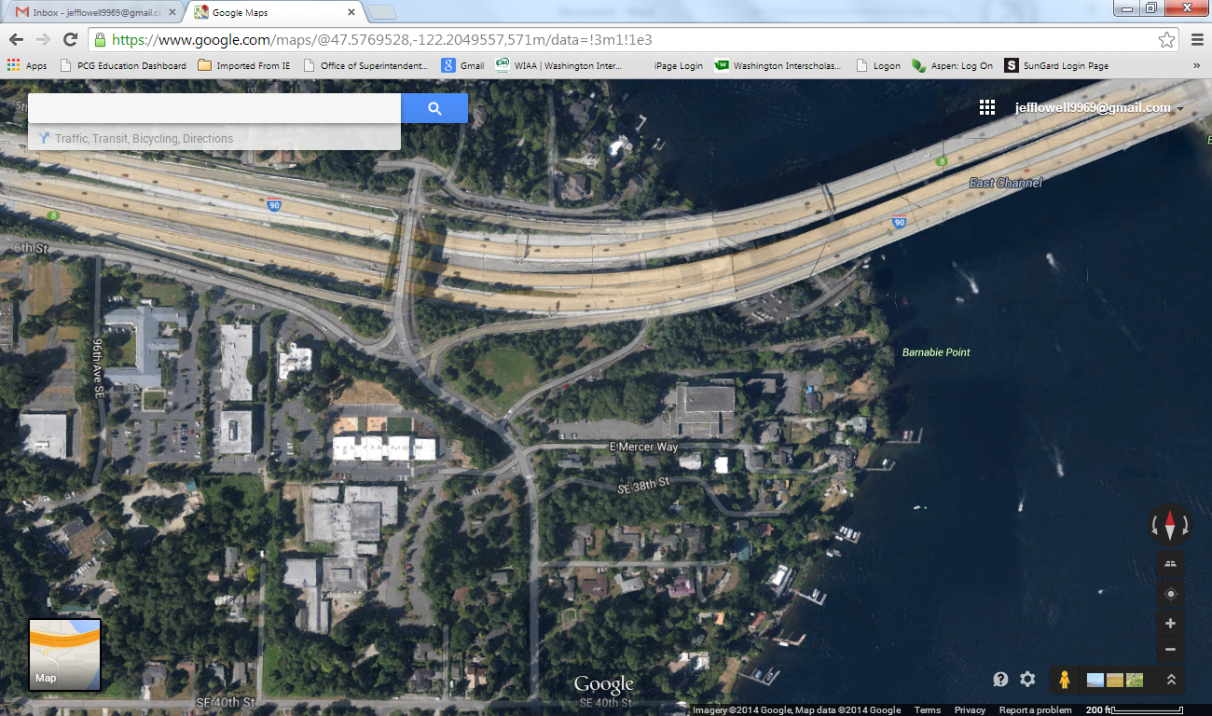

**Additional BUS parking at: Mercer Island Boat Launch**

Drive 1.2 miles, 3 min

Take Gallagher Hill Rd and SE 36th St to E Mercer Way 0.8 mi / 2 min

Continue onto E Mercer Way 482 ft / 15 s

Follow Frontage Rd to your destination 0.3 mi / 1 min

Turn left onto Frontage Rd 0.3 mi

Turn left 85 ft